Experiment No. 9

You are given a table, *Projects*, containing three

columns: *Task_ID*, *Start_Date* and *End_Date*. It is guaranteed that the difference betweenthe *End_Date* and the *Start_Date* is equal to *1* day for each row in the table.

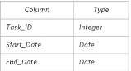

If the *End_Date* of the tasks are consecutive, then they are part of the same project. Samantha is interested in finding the total number of different projects completed.

Write a query to output the start and end dates of projects listed by the number of days it took to complete the project in ascending order. If there is more than one project that have the same number of completion days, then order by the start date of the project.

**Objective:** To understand the usage of Date data type and implementation of nested queries

Solution:

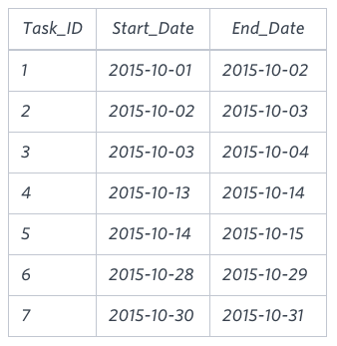

**Explanation**

The example describes following *four* projects:

* *Project 1*: Tasks *1*, *2* and *3* are completed on consecutive days, so these are part of the project. Thus start date of project is *2015–10–01* and end date is *2015–10–04*, so it took *3 days* to complete the project.
* *Project 2*: Tasks *4* and *5* are completed on consecutive days, so these are part of the project. Thus, the start date of project is *2015–10–13* and end date is *2015–10–15*, so it took *2 days* to complete the project.
* *Project 3*: Only task *6* is part of the project. Thus, the start date of project is *2015–10–28* and end date is *2015–10–29*, so it took *1 day* to complete the project.
* *Project 4*: Only task *7* is part of the project. Thus, the start date of project is *2015–10–30* and end date is *2015–10–31*, so it took *1 day* to complete the project.

Query

* create table projects(Task_id int, Start_date date, End_Date date );
* Insert into projects values(1,'2015-10-01','2015-10-02');
* Insert into projects values(2,'2015-10-02','2015-10-03');
* Insert into projects values(3,'2015-10-03','2015-10-04');
* Insert into projects values(4,'2015-10-13','2015-10-14');
* Insert into projects values(5,'2015-10-14','2015-10-15');
* Insert into projects values(6,'2015-10-28','2015-10-29');
* Insert into projects values(7,'2015-10-30','2015-10-31');
* Select*from projects;
* SELECT Start_Date, min(End_Date) FROM
* (SELECT Start_Date FROM Projects WHERE Start_Date NOT IN (SELECT End_Date FROM Projects)) a ,
* (SELECT End_Date FROM Projects WHERE End_Date NOT IN (SELECT Start_Date FROM Projects)) b
* WHERE Start_Date < End_Date GROUP BY Start_Date;**Sample**

